Macroplastics

2023-01-07

library(tidyverse)

## ── Attaching packages ─────────────────────────────────────── tidyverse 1.3.2 ──  
## ✔ ggplot2 3.4.0 ✔ purrr 1.0.0   
## ✔ tibble 3.1.8 ✔ dplyr 1.0.10  
## ✔ tidyr 1.2.1 ✔ stringr 1.5.0   
## ✔ readr 2.1.3 ✔ forcats 0.5.2   
## ── Conflicts ────────────────────────────────────────── tidyverse_conflicts() ──  
## ✖ dplyr::filter() masks stats::filter()  
## ✖ dplyr::lag() masks stats::lag()

library(readxl)  
library(plotrix)  
macroplastics <- read_excel("~/Desktop/MB5001 Macroplastics Data.xlsx")

For average count per site with standard error bars:

site_summary <- macroplastics %>%   
 group_by(Site) %>%   
 summarise(mean = mean(Count), std_error = std.error(Count))  
  
ggplot(site_summary, aes(x = Site, y = mean)) +  
 geom_bar(stat = "identity") +  
 geom_errorbar(aes(ymin = mean - std_error, ymax = mean + std_error), width = 0.4, size = 0.4) +  
 labs(x = "Site", y = "Mean rubbish count per tidal line (+/- SE)")

## Warning: Using `size` aesthetic for lines was deprecated in ggplot2 3.4.0.  
## ℹ Please use `linewidth` instead.

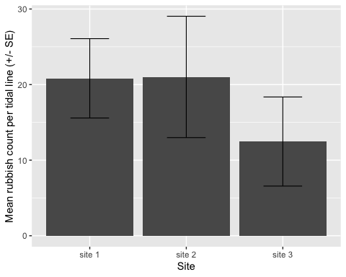

For average count per tidal line with standard error bars:

tidal_summary <- macroplastics %>%   
 group_by(Tidal_line) %>%   
 summarise(mean = mean(Count), std_error = std.error(Count))  
  
tidal_summary$Tidal_line = factor(tidal_summary$Tidal_line, levels = c('water', 'low', 'high', 'vegetation', 'grass'))  
  
  
ggplot(tidal_summary, aes(x = Tidal_line, y = mean)) +  
 geom_bar(stat = "identity") +  
 geom_errorbar(aes(ymin = mean - std_error, ymax = mean + std_error), width = 0.4, size = 0.4) +  
 labs(x = "Tidal line", y = "Mean rubbish count (+/- SE)")

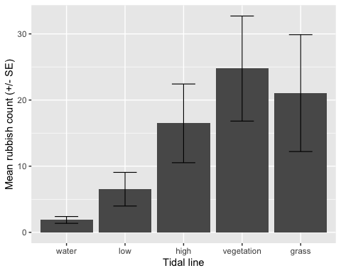

For average count per tidal line with standard error bars, separated by site:

plastics_summary <- macroplastics %>%   
 group_by(Tidal_line, Site) %>%   
 summarise(mean = mean(Count), std_error = std.error(Count))

## `summarise()` has grouped output by 'Tidal_line'. You can override using the  
## `.groups` argument.

plastics_summary$Tidal_line = factor(plastics_summary$Tidal_line, levels = c('water', 'low', 'high', 'vegetation', 'grass'))  
  
ggplot(plastics_summary, aes(x = Tidal_line, y = mean)) +  
 geom_bar(stat = "identity") +  
 geom_errorbar(aes(ymin = mean - std_error, ymax = mean + std_error), width = 0.4, size = 0.4) +  
 labs(x = "Tidal line", y = "Mean rubbish count per tidal line per site (+/- SE)") +  
 facet_wrap(~ Site)

